ASSESSMENT OF THE IMPACT OF TEA FARMING ON RURAL LIVELIHOODS AND ENVIRONMENTAL SUSTAINABILITY IN KABIANGA WARD, KERICHO COUNTY

A RESEARCH PROJECT PROPOSAL

SUBMITTED IN PARTIAL FULFILMENT OF THE REQUIREMENTS FOR THE AWARD OF THE BACHELOR'S DEGREE IN ENVIRONMENTAL PLANNING AND MANAGEMENT

BY
[STUDENT NAME]
[REGISTRATION NUMBER]

[UNIVERSITY NAME]
[DEPARTMENT / SCHOOL]
2026

DECLARATION
I declare that this research project proposal is my original work and has not been submitted to any other institution for academic award. All sources used have been acknowledged through appropriate citations and references.
Student's signature: _________________________ Date: __________________
Supervisor's approval: This proposal has been submitted for examination with my approval as the university supervisor.
Supervisor's signature: ______________________ Date: __________________

DEDICATION
This work is dedicated to my family, lecturers, classmates, and all smallholder farmers whose efforts continue to shape rural livelihoods and environmental stewardship in Kenya.

ACKNOWLEDGEMENT
I acknowledge the support of my supervisor, lecturers, classmates, family, and the respondents who will participate in this study. Their guidance and cooperation will make this research possible.

ABSTRACT
Tea farming is a major land-use and livelihood activity in many highland areas of Kenya. In Kabianga Ward, Kericho County, tea production contributes to household income, employment, education, food security, and rural economic activity. At the same time, continued dependence on tea farming raises environmental planning concerns related to soil fertility decline, land-use pressure, monocropping, chemical fertilizer use, erosion risk, and climate variability. This study proposes to assess the impact of tea farming on rural livelihoods and environmental sustainability in Kabianga Ward, Kericho County. The study will be guided by four objectives: to examine the contribution of tea farming to rural livelihoods; to assess the environmental effects associated with tea farming practices; to identify challenges affecting sustainable tea farming; and to propose environmental management strategies for improving sustainability. A descriptive survey research design will be used. The study will collect primary data mainly through structured questionnaires administered to smallholder tea farmers, supported by key informant interviews and field observation. Secondary data will be obtained from relevant books, journals, institutional reports, county documents, and policy documents. Quantitative data will be analyzed using descriptive statistics such as frequencies, percentages, means, tables, and charts, while qualitative data will be analyzed thematically. The study is expected to generate useful information for farmers, county planners, environmental managers, agricultural extension officers, policymakers, and researchers interested in sustainable land use and rural livelihood improvement.

TABLE OF CONTENTS
DECLARATION | 2
DEDICATION | 3
ACKNOWLEDGEMENT | 4
ABSTRACT | 5
TABLE OF CONTENTS | 6
LIST OF TABLES AND FIGURES | 7
ABBREVIATIONS AND ACRONYMS | 8
CHAPTER ONE: INTRODUCTION | 9
1.1 Background of the Study | 9
1.2 Problem Statement | 10
1.3 Objectives, Research Questions and Premises | 11
1.4 Justification of the Study | 13
1.5 Significance, Scope and Limitations | 13
CHAPTER TWO: LITERATURE REVIEW | 15
2.1-2.9 Literature Review Sections | 15
CHAPTER THREE: AREA OF STUDY | 19
3.1-3.4 Location, Physical, Economic and Social Features | 19
CHAPTER FOUR: RESEARCH DESIGN AND METHODOLOGY | 21
4.1-4.7 Design, Data, Sampling, Collection and Analysis | 21
CHAPTER FIVE: DATA PRESENTATION, ANALYSIS AND DISCUSSION | 26
CHAPTER SIX: SUMMARY, CONCLUSIONS AND RECOMMENDATIONS | 28
REFERENCES | 29
APPENDICES | 30

LIST OF TABLES
Table 1.1: Objectives, research questions and premises
Table 3.1: Summary of key study area characteristics
Table 4.1: Target respondents and sampling approach
Table 4.2: Data needs and sources
Table 4.3: Data analysis matrix
Table 5.1: Planned questionnaire response summary table
Appendix C: Proposed budget

LIST OF FIGURES
Figure 2.1: Conceptual framework linking tea farming, livelihoods and environmental sustainability
Figure 4.1: Proposed research process
Appendix D: Proposed Work Plan / Gantt Chart

ABBREVIATIONS AND ACRONYMS
Acronym | Meaning
EPM | Environmental Planning and Management
FAO | Food and Agriculture Organization of the United Nations
KNBS | Kenya National Bureau of Statistics
KTDA | Kenya Tea Development Agency
NEMA | National Environment Management Authority
SPSS | Statistical Package for the Social Sciences
TBK | Tea Board of Kenya

CHAPTER ONE: INTRODUCTION

1.1 Background of the Study
Tea is one of the most important agricultural commodities in Kenya and remains a major source of income for many rural households in tea-growing highland regions. Nationally, the tea industry contributes to export earnings, employment creation, rural infrastructure development, and household welfare. The Tea Board of Kenya reported that total tea earnings in 2024 reached Ksh. 215.21 billion, with a large share generated through exports (Tea Board of Kenya, 2024). KTDA also indicates that smallholder tea farmers remain central to Kenya's tea sector, contributing a significant proportion of national tea production through farmer-owned tea companies and factory systems (KTDA, n.d.).
In rural areas, tea farming is not only an economic activity but also a land-use system that shapes settlement patterns, labour allocation, household income, education decisions, food purchases, farm investment, and local trade. The Sustainable Livelihoods Framework views livelihood outcomes as products of assets, activities, institutions, and vulnerability contexts. This makes it useful for examining how tea farming supports or constrains household welfare while interacting with natural resources such as land, water, soil, and vegetation (DFID, 1999; Chambers & Conway, 1991).
For Environmental Planning and Management, tea farming deserves attention because it connects human livelihoods to environmental systems. The crop is usually cultivated for many years on the same land, making long-term land management practices important. Poorly managed tea farms may face challenges such as soil nutrient depletion, erosion on slopes, loss of on-farm biodiversity, chemical fertilizer dependence, and reduced resilience to climate shocks. Conversely, well-managed tea farming can support soil conservation, stable vegetation cover, agroforestry, household income, and planned rural development.
Climate variability is becoming an important issue in tea-growing regions. Tea production is sensitive to rainfall, temperature, soil moisture, and extreme events. Research on tea and climate adaptation shows that farmers may respond through crop diversification, soil conservation, agroforestry, and adoption of more climate-resilient varieties (Muench et al., 2021). In Kenya, studies on small-scale tea and coffee farmers have also identified climate change as a threat to farm productivity and rural livelihoods, making adaptation and environmental management increasingly necessary (Karuri, 2021).
Kabianga Ward in Kericho County lies within one of Kenya's major tea-growing landscapes. Many households depend directly or indirectly on tea farming. However, continued reliance on tea raises questions about how tea production affects livelihoods and whether current land-use practices are environmentally sustainable. This study will therefore assess the impact of tea farming on rural livelihoods and environmental sustainability in Kabianga Ward, Kericho County.

1.2 Problem Statement
Tea farming contributes to rural livelihoods in Kabianga Ward through income generation, employment, household welfare support, and local economic activity. However, the same farming system may also create or intensify environmental management challenges when land is continuously used for tea monocropping without adequate soil conservation, organic matter replenishment, shade management, or sustainable input use.
Smallholder tea farmers may experience unstable income because of fluctuating farm-gate returns, rising production costs, labour demands, climate variability, and changes in market conditions. These livelihood pressures can reduce the ability of households to invest in sustainable farming practices. Environmental challenges such as soil fertility decline, erosion, reduced biodiversity, chemical input dependence, and vulnerability to drought or excess rainfall may in turn affect tea productivity and household welfare.
Although tea farming has been widely studied at national and industry levels, there is a need for more localized research that links rural livelihoods with environmental sustainability at ward level. Without such information, environmental planners, county agricultural officers, farmers, and policymakers may lack adequate evidence for promoting sustainable land-use interventions. This study therefore seeks to assess the impact of tea farming on rural livelihoods and environmental sustainability in Kabianga Ward, Kericho County.

1.3 Objectives, Research Questions and Premises

1.3.1 General Objective
To assess the impact of tea farming on rural livelihoods and environmental sustainability in Kabianga Ward, Kericho County.

1.3.2 Specific Objectives
- To examine the contribution of tea farming to rural livelihoods among smallholder farmers in Kabianga Ward.
- To assess the environmental effects associated with tea farming practices in Kabianga Ward.
- To identify the challenges affecting sustainable tea farming among smallholder farmers in Kabianga Ward.
- To propose environmental management strategies for improving the sustainability of tea farming in Kabianga Ward.

1.3.3 Research Questions
- How does tea farming contribute to rural livelihoods among smallholder farmers in Kabianga Ward?
- What environmental effects are associated with tea farming practices in Kabianga Ward?
- What challenges affect sustainable tea farming among smallholder farmers in Kabianga Ward?
- What environmental management strategies can improve the sustainability of tea farming in Kabianga Ward?

1.3.4 Premises of the Study
- Tea farming contributes significantly to household income, employment, education support, and rural welfare among smallholder farmers in Kabianga Ward.
- Tea farming practices may have both positive and negative effects on environmental sustainability depending on land-use management, soil conservation, input use, and adaptation measures.
- Sustainable tea farming in Kabianga Ward is influenced by economic, environmental, institutional, and climate-related factors.
- Environmental planning strategies such as soil conservation, agroforestry, farmer training, and sustainable input management can improve the long-term sustainability of tea farming.
Specific objective | Research question | Premise
To examine the contribution of tea farming to rural livelihoods among smallholder farmers in Kabianga Ward. | How does tea farming contribute to rural livelihoods among smallholder farmers in Kabianga Ward? | Tea farming contributes significantly to household income, employment, education support, and rural welfare among smallholder farmers in Kabianga Ward.
To assess the environmental effects associated with tea farming practices in Kabianga Ward. | What environmental effects are associated with tea farming practices in Kabianga Ward? | Tea farming practices may have both positive and negative effects on environmental sustainability depending on land-use management, soil conservation, input use, and adaptation measures.
To identify the challenges affecting sustainable tea farming among smallholder farmers in Kabianga Ward. | What challenges affect sustainable tea farming among smallholder farmers in Kabianga Ward? | Sustainable tea farming in Kabianga Ward is influenced by economic, environmental, institutional, and climate-related factors.
To propose environmental management strategies for improving the sustainability of tea farming in Kabianga Ward. | What environmental management strategies can improve the sustainability of tea farming in Kabianga Ward? | Environmental planning strategies such as soil conservation, agroforestry, farmer training, and sustainable input management can improve the long-term sustainability of tea farming.

1.4 Justification of the Study
This study is justified because tea farming is a major source of rural livelihood in Kabianga Ward, yet its environmental implications require careful assessment from an Environmental Planning and Management perspective. Understanding the balance between livelihood benefits and environmental sustainability will help identify whether current practices support long-term rural development.
The study will also provide localized information that can guide planning decisions at household, ward, and county levels. Since environmental planning requires evidence on land use, resource management, community welfare, and sustainability risks, this research will contribute practical information for designing farmer-focused interventions.

1.5 Significance of the Study
- Farmers may benefit from recommendations on sustainable tea farming, soil conservation, and livelihood diversification.
- County planners and environmental managers may use the findings to strengthen sustainable land-use planning and community-based environmental management.
- Agricultural extension officers may use the findings to improve farmer training on soil fertility, erosion control, climate adaptation, and sustainable input use.
- Policy makers may benefit from evidence on how tea farming links livelihood outcomes with environmental sustainability.
- Researchers and students may use the study as a reference for future research on sustainable agriculture, rural livelihoods, and environmental planning.

1.6 Scope of the Study
The study will be conducted in Kabianga Ward, Kericho County. It will focus on smallholder tea farmers and will assess how tea farming affects rural livelihoods and environmental sustainability. Livelihood indicators will include income, employment, education support, household welfare, food security, and dependence on tea. Environmental sustainability indicators will include soil fertility, soil erosion, vegetation cover, chemical input use, water and climate sensitivity, and adoption of sustainable farming practices. The study will use questionnaires as the main primary data collection tool, supported by interviews and observation.

1.7 Limitations of the Study
- Some respondents may not provide accurate income or production information due to privacy concerns or poor record keeping.
- Weather and accessibility conditions may affect field data collection schedules.
- The study will be limited to selected respondents within Kabianga Ward and may not represent all tea-growing areas in Kenya.
- The results will depend on the quality of questionnaire responses and willingness of participants to cooperate.

CHAPTER TWO: LITERATURE REVIEW

2.1 Introduction
This chapter reviews literature related to tea farming, rural livelihoods, environmental sustainability, sustainable agriculture, and environmental planning. The review is organized around the objectives of the study and identifies gaps that justify the proposed research in Kabianga Ward.

2.2 Tea Farming and Rural Livelihoods
Tea farming supports rural livelihoods by providing income, employment, and market linkages. In Kenya, tea contributes to national export earnings and supports many smallholder farmers through production, processing, transport, marketing, and related services. The Tea Board of Kenya reported strong national tea earnings in 2024, demonstrating the continuing economic importance of the sector (Tea Board of Kenya, 2024).
At household level, tea income may support school fees, food purchases, health care, housing, savings, and farm investment. However, the extent of livelihood benefits varies depending on farm size, productivity, labour availability, input costs, payment systems, market conditions, and household expenditure priorities. The Sustainable Livelihoods Framework emphasizes that livelihood outcomes depend not only on income but also on access to assets, institutions, and capacity to cope with shocks (DFID, 1999).

2.3 Environmental Sustainability in Tea Farming
Environmental sustainability in tea farming refers to the ability of tea production systems to maintain soil fertility, conserve water, reduce erosion, protect biodiversity, minimize harmful input use, and remain productive without degrading the natural resource base. Since tea is a perennial crop, it can provide continuous vegetation cover that may reduce surface runoff where farms are well managed. However, long-term monocropping, inappropriate fertilizer use, poor drainage, and inadequate soil conservation may contribute to environmental stress.
Soil quality is a key issue in sustainable agriculture. Land degradation studies in Kenya show that soil nutrient depletion, erosion, and unsustainable land management can reduce agricultural productivity and ecological resilience (Mganga et al., 2022). In tea landscapes, soil conservation, organic matter management, mulching, contour farming, and appropriate fertilizer use are important for maintaining long-term production.

2.4 Climate Variability and Tea Production
Tea production depends strongly on suitable rainfall, temperature, and soil moisture conditions. Climate variability may affect tea through drought stress, excessive rainfall, changing pest pressure, and altered flushing patterns. Reports from the Tea Board of Kenya have linked monthly tea production fluctuations to rainfall and temperature conditions in both East and West of Rift tea-growing regions (Tea Board of Kenya, 2024).
Research on smallholder tea farmers indicates that adaptation strategies may include soil conservation, crop diversification, agroforestry, water conservation, and adoption of less climate-sensitive cultivars (Muench et al., 2021). For Kenya, climate change literature also points to the need for adaptation and mitigation measures in tea and coffee sectors because small-scale producers are vulnerable to changes in climate conditions (Karuri, 2021; UNIDO, 2016).

2.5 Sustainable Land Use and Environmental Planning
Environmental planning is concerned with guiding land use in ways that balance human needs with environmental protection. In tea-growing areas, planning must consider household livelihoods, soil conservation, water management, infrastructure, biodiversity, climate resilience, and agricultural productivity. Sustainable land-use planning can help prevent degradation while supporting rural economic development.
Tea farming areas require integrated management because livelihood pressure may lead households to intensify production, expand cultivation, or reduce environmental conservation investments. Environmental planning can support solutions such as farmer training, soil testing, agroforestry promotion, proper drainage, land-use zoning, conservation agriculture, and climate-smart agriculture.

2.6 Challenges Affecting Sustainable Tea Farming
Smallholder tea farmers face challenges that affect both livelihoods and environmental sustainability. These include high input costs, labour demands, price fluctuations, small farm sizes, limited credit access, climate variability, inadequate extension support, soil fertility decline, and limited diversification. These challenges may reduce farmers' capacity to adopt sustainable environmental practices.
The global tea sector also faces changing consumer demand, competition, and market volatility. FAO's Intergovernmental Group on Tea provides a forum for reviewing production, consumption, trade, and price trends in the tea sector (FAO, 2024). Such market dynamics indirectly affect smallholder farmers because price changes influence household income and investment decisions.

2.7 Theoretical Framework

2.7.1 Sustainable Livelihoods Framework
The Sustainable Livelihoods Framework is relevant to this study because it explains how households use assets and activities to secure livelihoods while responding to vulnerability contexts such as climate variability, market changes, and institutional conditions. The framework considers human, natural, financial, physical, and social capital. It is suitable for assessing how tea farming contributes to rural livelihoods and how environmental conditions influence household outcomes (DFID, 1999; Chambers & Conway, 1991).

2.7.2 Sustainable Agriculture Theory
Sustainable agriculture theory emphasizes production systems that are economically viable, socially acceptable, and environmentally sound. In this study, the theory helps examine whether tea farming practices in Kabianga Ward support current household needs without undermining soil, water, biodiversity, and future production potential.

2.8 Conceptual Framework
The conceptual framework proposes that tea farming practices influence both livelihood outcomes and environmental outcomes. These relationships are affected by contextual factors such as climate variability, market conditions, farm size, and extension support. Environmental planning and management responses can strengthen positive livelihood outcomes while reducing negative environmental effects.
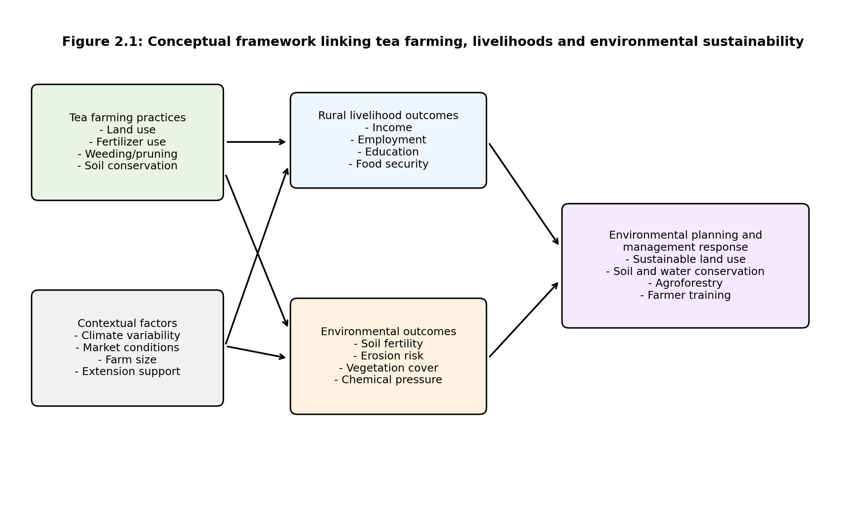
Source: Researcher's conceptualization, 2026.

2.9 Research Gaps
Existing literature provides useful information on tea production, climate adaptation, sustainable livelihoods, and land degradation. However, many studies focus on national or broad sectoral trends. There is a need for localized research that simultaneously examines rural livelihood benefits and environmental sustainability implications of tea farming at ward level. This study addresses that gap by focusing on smallholder tea farmers in Kabianga Ward, Kericho County.

CHAPTER THREE: AREA OF STUDY

3.1 Location of the Study
The study will be conducted in Kabianga Ward, Kericho County, Kenya. Kericho County is widely known for tea production due to its highland conditions and agricultural landscape. Kabianga Ward forms part of the rural tea-growing environment where smallholder farming is an important livelihood activity. The exact villages and sample locations will be confirmed during reconnaissance and sampling frame development.

3.2 Physical Features
The physical environment of Kabianga Ward is characterized by highland agricultural conditions suitable for tea farming. Key physical aspects relevant to this study include rainfall reliability, soil characteristics, slope, drainage, vegetation cover, and land-use patterns. These features influence tea productivity, soil conservation needs, erosion risk, and environmental sustainability.

3.3 Economic Features
The local economy is largely influenced by agriculture, with tea farming forming an important source of household income and employment. Related economic activities include farm labour, transport, input supply, local trade, small businesses, and service provision. The study will examine how tea farming contributes to income, employment, education financing, household welfare, and local economic stability.

3.4 Social Features
The social features of the study area include rural households, farmer networks, family labour systems, community institutions, farmer groups, churches, schools, and local leadership structures. Tea farming may influence social welfare by supporting education, health care, housing, social participation, and household decision-making. The study will collect information from smallholder tea farmers and selected key informants to understand these social dimensions.
Feature | Description | Relevance to the study
Location | Kabianga Ward, Kericho County | Defines the geographical scope of the study
Physical environment | Highland agricultural landscape with tea farming potential | Influences soil, water, vegetation and farming sustainability
Economic activity | Agriculture, tea farming and related services | Links tea farming to livelihoods and rural income
Social setting | Rural households and community institutions | Shapes labour, welfare, decision-making and adaptation

CHAPTER FOUR: RESEARCH DESIGN AND METHODOLOGY

4.1 Research Design
The study will adopt a descriptive survey research design. This design is appropriate because the study seeks to describe and analyze the existing relationship between tea farming, rural livelihoods, and environmental sustainability among smallholder tea farmers in Kabianga Ward. The design will allow collection of both quantitative and qualitative data through questionnaires, interviews, observation, and document review.
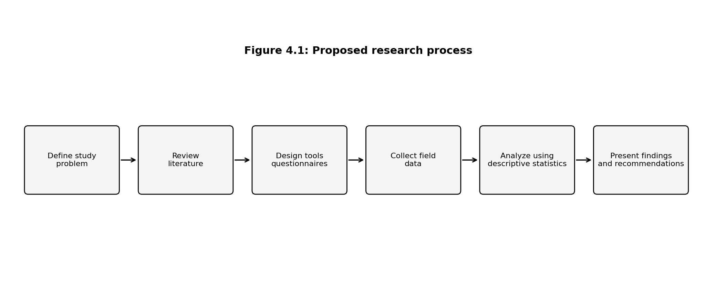
Source: Researcher's design, 2026.

4.2 Types and Sources of Data
The study will use both primary and secondary data. Primary data will be collected directly from respondents using structured questionnaires, key informant interviews, and field observation. Secondary data will be obtained from books, journals, institutional reports, government publications, county documents, and credible online sources.
Data type | Source | Purpose
Primary quantitative data | Questionnaires administered to smallholder tea farmers | To measure livelihood and environmental sustainability indicators
Primary qualitative data | Key informant interviews and observation | To explain farmer experiences, practices and local environmental issues
Secondary data | Reports, journals, policy documents and official statistics | To support literature review and contextual analysis

4.3 Target Population and Sampling
The target population will include smallholder tea-farming households in Kabianga Ward. Key informants may include agricultural extension officers, local administrators, environmental officers, farmer group leaders, and other stakeholders with knowledge of tea farming and environmental management in the area.

4.3.1 Sample Size
The study proposes a minimum of 100 smallholder tea-farming household respondents for the questionnaire survey. This sample size is considered manageable for an undergraduate field project and adequate for generating descriptive statistics. The final sample may be adjusted after confirming the sampling frame and supervisor guidance. Additional key informants will be selected purposively based on their knowledge of tea farming, rural livelihoods, and environmental management.

4.3.2 Sampling Techniques
The study will use a combination of stratified random sampling and purposive sampling. Smallholder tea farmers will be selected from different villages or sub-areas within Kabianga Ward to improve representation. Key informants will be selected purposively because they possess specialized knowledge relevant to the research objectives.
Respondent category | Proposed sample | Sampling technique | Reason
Smallholder tea farmers | 100 | Stratified/random sampling | Main source of questionnaire data
Agricultural/environmental officers | 2-4 | Purposive sampling | Technical knowledge on farming and sustainability
Local leaders/farmer group leaders | 3-5 | Purposive sampling | Community and farmer organization knowledge

4.4 Data Collection Methods

4.4.1 Questionnaires
Questionnaires will be the main method of primary data collection. They will be administered to smallholder tea farmers in Kabianga Ward. The questionnaire will include both closed-ended and open-ended questions covering household characteristics, tea farming activities, livelihood contribution, environmental effects, sustainability challenges, and proposed management strategies. The questionnaire is also formatted in Appendix A as a Google Form-ready tool.

4.4.2 Key Informant Interviews
Key informant interviews will be used to collect detailed qualitative information from people with technical or community-level knowledge of tea farming, environmental management, land-use issues, and rural development in Kabianga Ward.

4.4.3 Field Observation
Field observation will be used to record visible environmental conditions such as soil erosion signs, slope management, vegetation cover, drainage, mulching, fertilizer storage, and farm conservation practices. Observations will support and validate questionnaire responses.

4.4.4 Secondary Data Review
Secondary data will be reviewed to provide background information, support literature review, and compare local findings with broader trends in tea farming, environmental sustainability, and rural livelihoods.

4.5 Validity and Reliability of Research Instruments
Validity will be enhanced by ensuring that questionnaire items are aligned with the research objectives and reviewed by the supervisor before data collection. A pilot test will be conducted with a small number of respondents outside the final sample to identify unclear questions. Reliability will be improved by using consistent wording, clear response options, and standardized administration procedures.

4.6 Ethical Considerations
- Participation will be voluntary and based on informed consent.
- Respondents will be informed about the purpose of the study before answering questions.
- Personal information will be treated confidentially and used only for academic purposes.
- Respondents will not be forced to answer questions they are uncomfortable with.
- The researcher will avoid plagiarism by acknowledging all sources used.

4.7 Data Analysis
Quantitative data collected through questionnaires will be coded and analyzed using descriptive statistics such as frequencies, percentages, means, tables, and charts. Excel, SPSS, or another suitable statistical tool may be used. Qualitative data from interviews and open-ended questionnaire responses will be analyzed thematically by identifying recurring patterns related to livelihoods, environmental effects, challenges, and management strategies.
Objective | Key data required | Analysis method | Expected presentation
To examine the contribution of tea farming to rural livelihoods among smallholder farmers in Kabianga Ward. | Income sources, employment, education support, household welfare, food security | Frequencies, percentages, cross-tabulation and thematic analysis | Tables, bar charts and narrative discussion
To assess the environmental effects associated with tea farming practices in Kabianga Ward. | Soil erosion, soil fertility, fertilizer use, vegetation cover, conservation practices | Frequencies, percentages and observation summaries | Tables, pie charts, bar charts and photographs where permitted
To identify the challenges affecting sustainable tea farming among smallholder farmers in Kabianga Ward. | Input costs, labour, climate risks, market issues, land constraints, extension access | Ranking, percentages and thematic analysis | Ranked tables and charts
To propose environmental management strategies for improving the sustainability of tea farming in Kabianga Ward. | Farmer recommendations, expert views and observed practices | Thematic analysis and synthesis | Strategy matrix and discussion

CHAPTER FIVE: DATA PRESENTATION, ANALYSIS AND DISCUSSION
This chapter will be completed after field data collection. The study will use questionnaire responses, interview notes, and observation records to present, analyze, and discuss findings according to the research objectives. No findings are presented at proposal stage to avoid fabricating data.

5.1 Data Presentation
Data will be presented using tables, bar charts, pie charts, percentages, and narrative summaries. The following table provides a proposed format for presenting questionnaire results after data collection.
Research objective | Planned table/chart | Data source | Status
Livelihood contribution of tea farming | Bar chart showing major livelihood benefits | Questionnaires | To be completed after data collection
Environmental effects of tea farming | Pie/bar chart showing reported environmental effects | Questionnaires and observation | To be completed after data collection
Challenges affecting sustainable tea farming | Ranked challenge table | Questionnaires and interviews | To be completed after data collection
Proposed management strategies | Strategy matrix | Questionnaires and interviews | To be completed after data collection

5.2 Data Analysis
After data collection, the researcher will analyze quantitative responses using descriptive statistics and qualitative responses using thematic analysis. The analysis will be organized according to the four specific objectives.

5.3 Discussion of Findings
The discussion will interpret the findings in relation to the literature reviewed in Chapter Two, the Sustainable Livelihoods Framework, sustainable agriculture theory, and the study objectives. The discussion will explain how tea farming affects household welfare and environmental sustainability in Kabianga Ward.

CHAPTER SIX: SUMMARY, CONCLUSIONS AND RECOMMENDATIONS
This chapter will be completed after data analysis. It will summarize the major findings, draw conclusions based on the objectives, provide recommendations, and suggest areas for further study.

6.1 Summary
To be completed after data collection and analysis.

6.2 Conclusions
To be completed after data collection and analysis.

6.3 Recommendations
Recommendations will be made for farmers, county planners, environmental managers, agricultural extension officers, and policy makers based on the findings.

6.4 Areas for Further Study
Possible future studies may include soil testing in tea farms, climate adaptation among tea farmers, land-use change analysis using GIS, and comparative studies between tea and alternative livelihood activities.

REFERENCES
Chambers, R., & Conway, G. (1991). Sustainable rural livelihoods: Practical concepts for the 21st century. Institute of Development Studies.
Department for International Development (DFID). (1999). Sustainable livelihoods guidance sheets. DFID.
Food and Agriculture Organization of the United Nations (FAO). (2024). Intergovernmental Group on Tea: Current global market situation and medium-term outlook. FAO.
Karuri, A. N. (2021). Adaptation of small-scale tea and coffee farmers in Kenya to climate change. In African Handbook of Climate Change Adaptation. Springer.
Kenya National Bureau of Statistics (KNBS). (2025). Economic Survey 2025. KNBS.
Kenya Tea Development Agency (KTDA). (n.d.). Global leader in quality teas. KTDA.
Mganga, K. Z., et al. (2022). Agricultural land degradation in Kenya. Springer.
Muench, S., et al. (2021). Climate change adaptation by smallholder tea farmers: A case study of Nepal. Climate and Development.
Tea Board of Kenya. (2024). Kenya tea industry performance report 2024. Tea Board of Kenya.
United Nations Industrial Development Organization (UNIDO). (2016). Adaptation and mitigation in the Kenyan tea industry. UNIDO.

APPENDICES

Appendix A: Questionnaire for Smallholder Tea Farmers
Title: Assessment of the Impact of Tea Farming on Rural Livelihoods and Environmental Sustainability in Kabianga Ward, Kericho County
Introduction: Dear respondent, I am conducting an academic study on tea farming, rural livelihoods, and environmental sustainability in Kabianga Ward. Your responses will be treated confidentially and used only for academic purposes. Participation is voluntary.

Section A: Demographic and Household Information
1. Gender: Male / Female / Prefer not to say
2. Age bracket: Below 25 / 25-34 / 35-44 / 45-54 / 55 and above
3. Highest level of education: None / Primary / Secondary / College / University / Other
4. Household size: 1-3 / 4-6 / 7-9 / 10 and above
5. Main occupation: Tea farmer / Mixed farmer / Business / Formal employment / Other

Section B: Tea Farming Characteristics
6. How many years have you practiced tea farming? 0-5 / 6-10 / 11-20 / Above 20
7. Approximate size of land under tea: Less than 0.5 acre / 0.5-1 acre / 1-2 acres / Above 2 acres
8. Do you depend on tea farming as your main source of income? Yes / No / Partly
9. How often do you harvest tea? Weekly / Fortnightly / Monthly / Other
10. Do you use hired labour in tea farming? Yes / No / Sometimes

Section C: Livelihood Contribution of Tea Farming
11. Tea farming contributes to household income: Strongly agree / Agree / Neutral / Disagree / Strongly disagree
12. Tea income helps pay school fees: Strongly agree / Agree / Neutral / Disagree / Strongly disagree
13. Tea farming creates employment for household or community members: Strongly agree / Agree / Neutral / Disagree / Strongly disagree
14. Tea income improves household food security: Strongly agree / Agree / Neutral / Disagree / Strongly disagree
15. What are the main benefits your household gets from tea farming? Open-ended

Section D: Environmental Sustainability
16. Have you observed soil erosion on or near your tea farm? Yes / No / Not sure
17. Have you observed changes in soil fertility over time? Improved / Declined / No change / Not sure
18. Which conservation practices do you use? Mulching / Terracing / Contour planting / Shade trees / Drainage channels / None / Other
19. How often do you apply fertilizer? Every season / Once per year / Rarely / Never
20. Do you think tea farming affects the environment in your area? Positively / Negatively / Both / Not sure. Explain briefly.

Section E: Challenges Affecting Sustainable Tea Farming
21. Which challenges affect your tea farming? High input costs / Labour shortage / Low prices / Climate variability / Soil fertility decline / Pests and diseases / Transport issues / Other
22. Rank the top three challenges affecting your tea farming.
23. Have climate changes affected tea production in your farm? Yes / No / Not sure. Explain briefly.
24. Do you receive extension or training services on sustainable tea farming? Regularly / Sometimes / Rarely / Never

Section F: Suggested Environmental Management Strategies
25. Which practices should be promoted to improve sustainable tea farming? Soil testing / Agroforestry / Organic manure / Terracing / Water conservation / Farmer training / Diversification / Other
26. What support would help farmers improve both income and environmental conservation?
27. What recommendations would you give to county planners or agricultural officers?

Appendix B: Google Form-Ready Questionnaire Structure
Create a Google Form with the following title and sections. The question types below are included to make transfer into Google Forms easier.
Google Form section | Question number(s) | Recommended question type
Consent and introduction | Consent confirmation | Multiple choice: I agree / I do not agree
Demographic information | 1-5 | Multiple choice / short answer
Tea farming characteristics | 6-10 | Multiple choice / short answer
Livelihood contribution | 11-15 | Likert scale and paragraph
Environmental sustainability | 16-20 | Multiple choice / checkbox / paragraph
Challenges | 21-24 | Checkbox / ranking / paragraph
Recommendations | 25-27 | Checkbox / paragraph

Suggested Google Form settings: do not collect email addresses unless required by the supervisor; allow only one response if respondents have access to unique accounts; keep responses anonymous; export responses to Google Sheets for analysis.

Appendix C: Key Informant Interview Guide
- What are the main livelihood benefits of tea farming in Kabianga Ward?
- What environmental issues are associated with tea farming in the area?
- What conservation practices are commonly used by tea farmers?
- How is climate variability affecting tea farming?
- What planning or management interventions would improve sustainable tea farming?

Appendix D: Proposed Budget
Item | Estimated cost (Ksh.) | Remarks
Printing questionnaires | 2,000 | Questionnaire copies and consent forms
Transport | 6,000 | Field visits within Kabianga Ward
Communication | 1,000 | Calls and coordination
Data entry and analysis | 2,000 | Data cleaning and analysis support
Printing and binding | 3,000 | Final proposal/report
Contingency | 2,000 | Unexpected costs
Total | 16,000 | Estimated budget

Appendix E: Proposed Work Plan
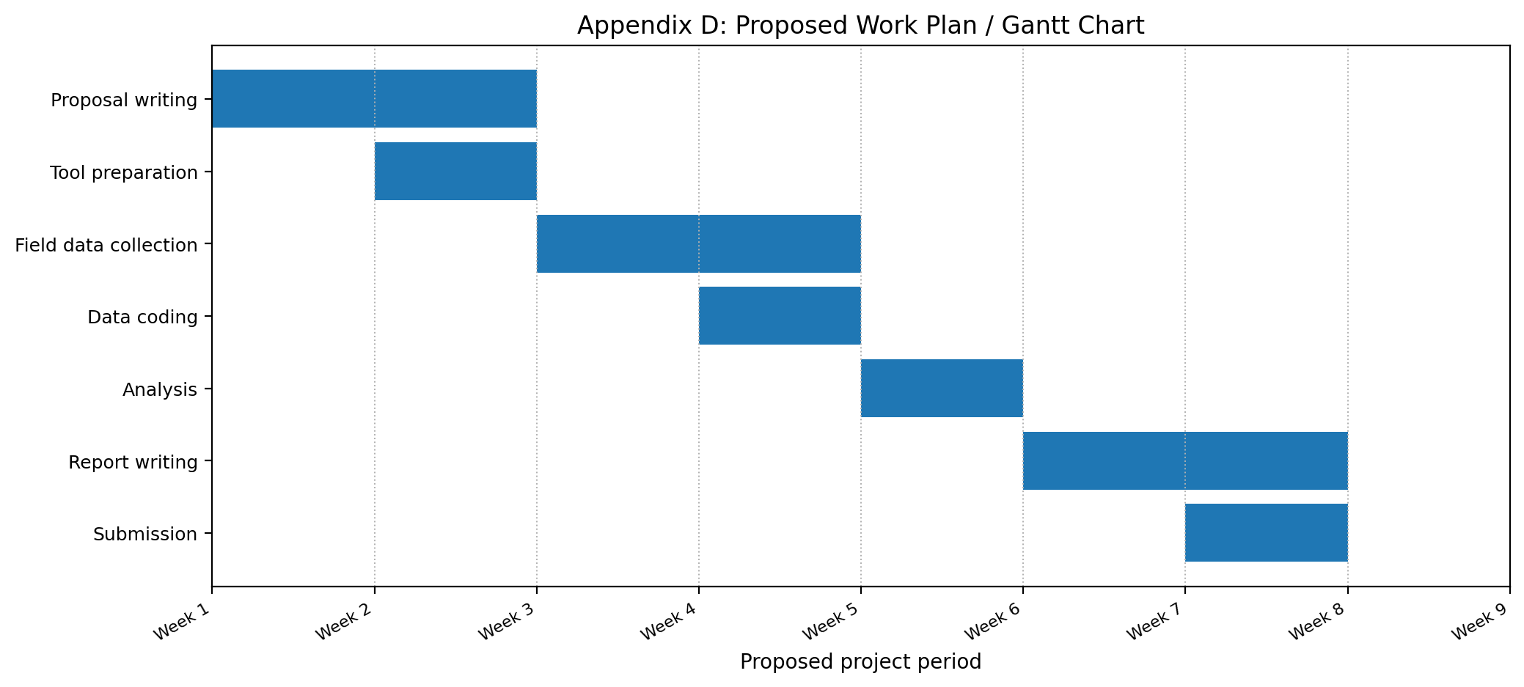

Appendix F: Consent Statement
I have understood the purpose of the study and agree to participate voluntarily. I understand that my responses will be kept confidential and used only for academic purposes. I may withdraw from the study at any time without penalty.
Respondent signature: ________________________ Date: __________________

